Three sources of difference between ADCPs and drifters: 1) heterogeneity in grid cell, 2) surface vs depth-averaged measurements, 3) influence of Stoke’s Drift on drifters.

In shallow water, at depth z, Stoke’s Drift in the direction of wave propagation is calculated

|  |  |  |
| --- | --- | --- |
| $$U_{Stoke}={\left( \frac{πH}{L}\right)}^{2} c \frac{\cos{h (2\left(h-z\right)\frac{2π}{L})}}{\sin{h^{2} (\frac{2πh}{L})}}$$ | $$depth ≤\frac{L}{20}$$ |  |
| where *UStoke* is Stoke’s Drift (m/s), *H* is wave height (m), *L* is wavelength (m), *k* is wave number (2π/L), *c* is wave speed, *h* is water depth (m), and *z* is depth from surface (m). | | |

Wave speed (*c*) is calculated:

|  |  |  |
| --- | --- | --- |
|  | $$c= \sqrt{\frac{g L}{2 π} tanh\left(2 π \frac{h}{L}\right)}$$ |  |
| where *g* is gravitational acceleration (=9.81 m/sec2). | | |

In shallow water, at depth z, wavelength is calculated by Nielsen’s (1982) methd:

|  |  |  |
| --- | --- | --- |
| $$L= \sqrt{2 π h L_{0}}* \left(1- \frac{h}{L_{0}}\right)$$ | $$depth ≤\frac{L_{0}}{20}$$ |  |
| where *L* is wavelength in shallow water (m), h is water depth (m), and *L0* is offshore or deep-water wavelength ( = *1.56 * T2* where *T* is wave period. | | |

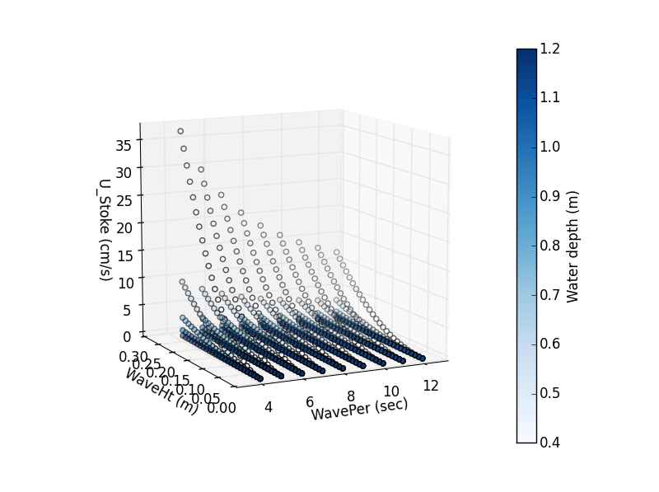

Figure . Stokes Drift (U_Stoke) (cm/sec) at the surface (z=0.01 m) for the expected range of wave height, wave period, and water depth experienced at the ADCPs. Interactive Plot at: https://plot.ly/33/~CaptainAl/

Maximum wave height measured on the reef flat in 2013 was 0.25 m, corresponding to an offshore wave height of 1.7 m (Vetter, unpublished data). Vetter (unpublished) did not provide data on wave periods but wave periods typically vary from 4-12 sec at the study site. Water depths over the ADCPs during drifter deployments varied from 0.4 – 1.2 m . For the expected range of wave heights (0-0.25 m), wave period (4-12 sec), and water depths (0.4-1.2 m) at the ADCPs, predicted UStoke varied from 0-37 cm/s. UStoke was highly sensitive to water depth, especially for larger wave heights and lower wave periods (Figure 1). UStoke was insensitive to the depth *z* where it was calculated.

While the magnitudes of UStoke calculated for the full range of conditions could explain the 0.1-18.8 cm/sec differences between drifters and ADCPs, magnitudes of UStoke > ~5 cm/sec should be considered extreme values, since the combination of high wave height and low wave period is unlikely, and the low water depth only persists for a short amount of time. A more likely range of UStoke influencing the drifters is actually more on the order of 0.1 to 3 cm/sec. While UStoke might be an important source of disagreement between Eulerian and Lagrangian estimates in some cases, it is likely not the cause of the largest disagreements.

(Falter et al. 2008): Unfortunately, our ADCPs generally excluded ~25 cm of the upper water column as a result of sidelobe interference near the free surface. Therefore we ran a numerical simulation of a current profile over the entire water column under average flow conditions using Delft3D (WL|Delft Hydraulics). The results of this simulation indi- cate that drifter speeds should exceed the depth-averaged current by 3 cm s?1 or 30% (Figure 13), thus explaining much of the discrepancy between observed Udr and UE+S